# 영상처리 HW5

16010980 이우석

## 출력 결과

* lena.pgm / lena_30angle.pgm / lena_60angle.pgm

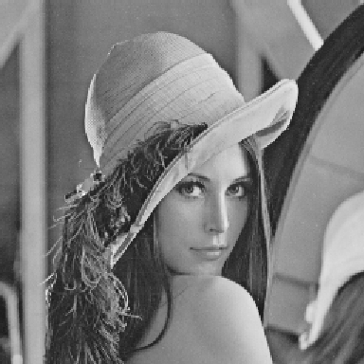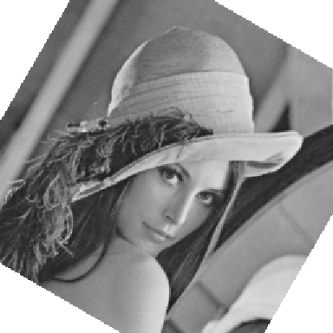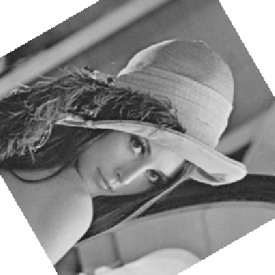

* czp.pgm / czp_30angle.pgm / czp_60angle.pgm

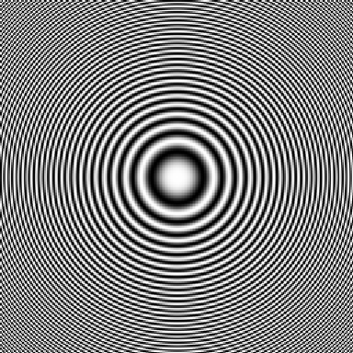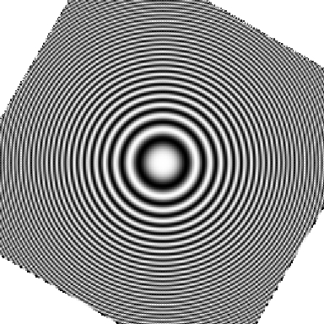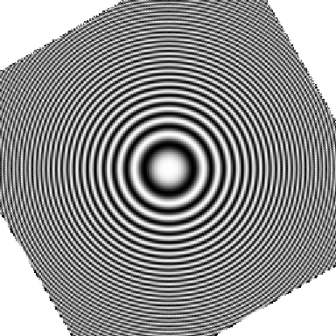

## 코드

void bilinear_rotation(image_ptr buffer, char* fileout, int rows, int cols,

float angle, int type)

{

unsigned long x, y; /* loop indices for columns and rows */

unsigned long index; /* index into line buffer */

unsigned long source_index; /* address of source pixel in image buffer */

unsigned char* line_buff; /* output line buffer */

int new_rows, new_cols; /* values of rows and columns for new image */

unsigned line; /* number of pixels in one scan line */

FILE* fp; /* output file pointer */

unsigned long X_Source, Y_Source; /* x and y address of source pixel */

pixel_ptr color_buff; /* pointer to a color image in memory */

int NW, NE, SW, SE, result;

float EWweight, NSweight, EWtop, EWbottom;

double radian = getRadian(angle); // radian 값을 받을 변수

unsigned long x_center, y_center; // 이미지의 중앙 좌표를 받을 변수

/* open new output file */

if ((fp = fopen(fileout, "wb")) == NULL)

{

printf("Unable to open %s for output\n", fileout);

exit(1);

}

// 중앙 부분의 좌표

x_center = cols / 2;

y_center = rows / 2;

/* print out the portable bitmap header */

// fprintf(fp, "P%d\n%d %d\n255\n", type, new_cols, new_rows);

fprintf(fp, "P%d\n%d %d\n255\n", type, cols, rows);

if (type == 5) /* PGM file */

line = cols;

else /* PPM file */

{

line = cols * 3;

color_buff = (pixel_ptr)buffer;

}

line_buff = (unsigned char*)malloc(line);

for (y = 0; y < rows; y++)

{

index = 0;

for (x = 0; x < cols; x++)

{

// 원본 파일의 좌표

X_Source = (unsigned long)(cos(radian) * ((double)x - x_center) + sin(radian) * ((double)y - y_center) + (double)x_center);

Y_Source = (unsigned long)((-1) * sin(radian) * ((double)x - x_center) + cos(radian) * ((double)y - y_center) + (double)y_center);

if (type == 5) /* PGM */

{

/* bilinear interpolation */

// duplicate the border edges

// X_Source, Y_Source 가 원본 이미지의 가로, 세로 크기를 넘지 않는다면,

if (0 <= X_Source && X_Source < cols && 0 <= Y_Source && Y_Source < rows)

{

NW = buffer[Y_Source * cols + X_Source];

if (X_Source + 1 >= cols && Y_Source + 1 >= rows)

{

NE = NW;

SW = NW;

SE = NW;

}

else if (X_Source + 1 >= cols)

{

NE = NW;

SW = buffer[(Y_Source + 1) * cols + X_Source];

SE = SW;

}

else if (Y_Source + 1 >= rows)

{

NE = buffer[Y_Source * cols + X_Source + 1];

SW = NW;

SE = NE;

}

else

{

NE = buffer[Y_Source * cols + X_Source + 1];

SW = buffer[(Y_Source + 1) * cols + X_Source];

SE = buffer[(Y_Source + 1) * cols + X_Source + 1];

}

// 가중치를 계산할 때에도,

EWweight = (cos(radian) * ((double)x - x_center) + sin(radian) * ((double)y - y_center) + (double)x_center) - (float)X_Source;

NSweight = ((-1) * sin(radian) * ((double)x - x_center) + cos(radian) * ((double)y - y_center) + (double)y_center) - (float)Y_Source;

EWtop = NW + EWweight * (NE - NW);

EWbottom = SW + EWweight * (SE - SW);

result = EWtop + NSweight * (EWbottom - EWtop);

line_buff[index++] = result;

}

// X_Source, Y_Source 가 원본 이미지의 가로, 세로 크기를 넘는다면,

else

{

// 흰색으로 표현함.

line_buff[index++] = 255;

}

}

else /* PPM */

{

line_buff[index++] = color_buff[source_index].r;

line_buff[index++] = color_buff[source_index].g;

line_buff[index++] = color_buff[source_index].b;

}

}

fwrite(line_buff, 1, line, fp);

}

fclose(fp);

}